**Introduction**

An electrocardiogram is a graphical representation of the heart’s electrical activity over a selected period of time. As the heart contracts, an ECG will detect the signal as well as amplify and filter it to produce a stable graph. Each peak on the ECG graph corresponds to different actions that occur in the heart chambers.

**Method**

For ECG signal acquisition, we used Bioradio 150 instead of the AD8232 because it offers a more stable signal that easily exports as a csv file and uses for analyzing in the biomedical toolkit. The csv file was converted into a tdms file before imported it into an ECG feature extractor to display the graph and analyze the QRS complex. As for the time-domain and frequency-domain analysis, it was done using the heart rate variability application.

**Result**

Below is the ECG signal that we analyzed. Other graphs such as QRS complex, R-R and heart rate histograms, and fast Fourier transform spectrum are shown in the powerpoint.

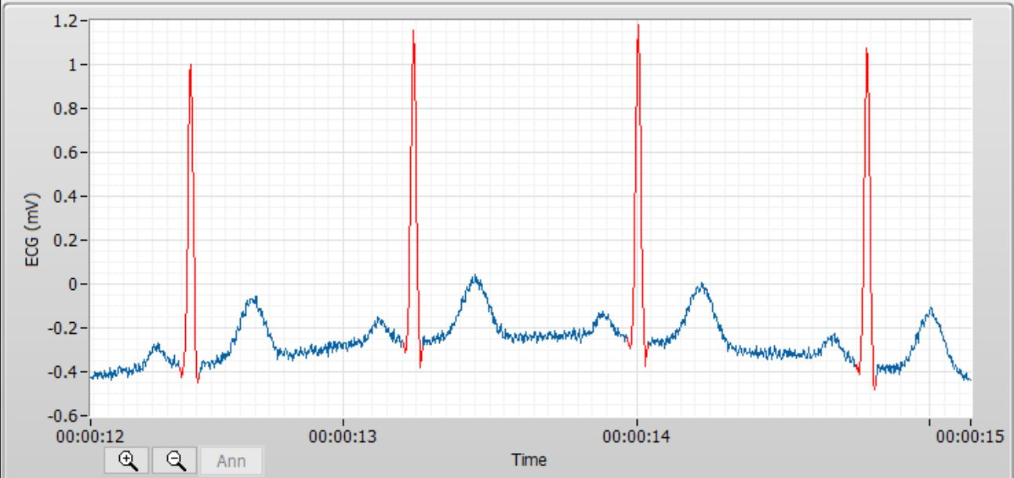

**Discussion**

The biomedical toolkit is a collection of ready-to-run applications designed to simplify the use of LABVIEW. With it, different components of the ECG graph can easily be analyzed. Furthermore, parameters such as filters and refinements of the signal can also be customized. For this lab, information such as mean and standard deviation of peaks, heart rate, number beats, RMSSD and HRV triangular index of R-R interval as well as the power of different frequency components were generated using this program.